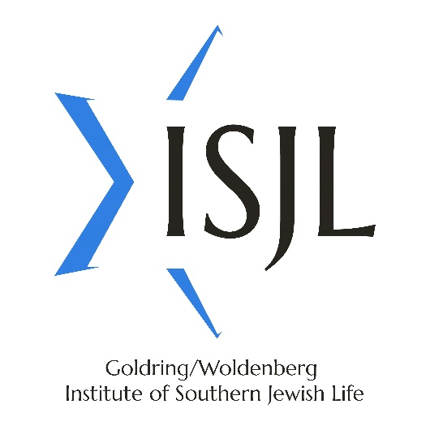
Press Release

FOR IMMEDIATE RELEASE:
July 1, 2021

FOR MORE INFORMATION:
ISJL Administration
information@isjl.org / 601-362-6357

Innovation at the ISJL:

Strategic Planning for Sustainable Impact

Jackson, MS – This year, the Goldring/Woldenberg Institute of Southern Jewish Life (ISJL) is rolling out a new strategic plan.

When it comes to strategic planning, and everything else, this has been a unique period of time in which to engage in reflection and reimagining. The ISJL began this strategic planning process in 2019 with the ISJL Listening Tour—a series of more than two dozen focus group conversations held in Jewish communities across the organization’s 13-state-region. At the onset of this process, traveling directly to communities in all thirteen states was a given. By the time the Listening Tour was wrapping up and the formal strategic planning process was kicking off, the COVID-19 pandemic was beginning to make headlines. The last two Listening Tour visits were conducted on Zoom. As the organization began the formal strategic planning process with consultant Debbie Joseph, this process too shifted to the online environment.

“No one was expecting what 2020 brought,” says the ISJL’s CEO, Michele Schipper. “But even in the face of the pandemic, it was never a question that we were going to continue serving our communities—and it was important to continue the strategic planning journey along the way.”

So even while going remote for 14 months, adjusting programmatic offerings, maintaining contact with communities, shifting services to online and developing all-new resources, over the pandemic year the ISJL also managed to stay the course with its strategic planning process. If anything, it became more relevant and vital: new approaches were being attempted out of short-term necessity, but taught important long-term lessons. As more than one ISJL board member commented: “We learned as much from the pandemic as from any other aspect of our strategic planning process.”

Informed by community members, funding partners, outside consultants, and current and former staff and board, the ISJL’s new strategic plan identifies several key focus areas and evolutions for the organization:

- A shift from six departments to three service areas. Since its founding in 2000, the ISJL has added many programs and services to its portfolio, ultimately housed within six distinct departments. However, with a focus on unifying and optimizing the ISJL’s approach, the organization now has three service areas: Culture, Education, and Spirituality.

- Streamlining of staff positions. Along with the restructuring of the six departments into three service areas, there was some necessary realignment of staff positions. No one was dismissed from their employment through the strategic planning process; however, some finite-term positions ended and were not refilled, and other roles were re-allocated. Over the course of this strategic planning process, the ISJL has gone from 24 full-time staff to 18—a Jewishly-significant number, and one which contributes to efficiency and long-term sustainability.

- New “Program Associate” roles. Since 2003, the ISJL has had “Education Fellows” who spent two immersive years as Jewish educators on the ISJL team. Immensely popular with the communities they served and incredibly impactful while at the ISJL as well as in their post-ISJL journeys, the Fellows are one of the ISJL’s “big wins.” However, in interviews past Fellows shared that the job title was often a barrier for them. Future employers had no idea what an “Education Fellow” was; it was often assumed that the position was academic, volunteer, or an unpaid internship rather than the paid full-time (with benefits) nonprofit employment it actually is. Funders, too, would often ask whether or not these “education interns” were paid. Based directly on this critical feedback, the ISJL Education Fellows are now the ISJL Program Associates. There are many reasons this title more accurately reflects their work; it aligns well with other nonprofit positions title-wise, it reflects that in addition to “education” they are gaining lots of hands-on programming experience, and the job title will hopefully translate clearly on resumes as well.

- New office location. For twenty years, the ISJL sat on Frontage Road in Jackson, Mississippi, in a rented industrial office building. As of May 2021, the ISJL offices are housed within Beth Israel Congregation in Jackson; the congregation and ISJL remain two separate entities, but the entire Jackson Jewish community benefits from the collegiality and cost-saving that this new arrangement brings.

- Community-centered approach. The communities served by the ISJL have always been the heart of the ISJL’s mission, but moving forward the ISJL is offering even more tailored options for how it serves communities. The needs of small southern Jewish congregations with no clergy or congregational staff are not the same as the needs of a community with its own rabbi and educator; the ISJL has resources for both communities but can serve them in different ways.

- Always focusing on small southern communities. While the ISJL will continue partnering with communities of all sizes, the organization was founded to meet the often unmet needs of smaller southern congregations. That special mandate will shape the organizational priorities and approach.

- Ongoing online offerings. Before the pandemic, very little ISJL programming was offered online. Now from conferences, concerts and text studies to cooking competitions and downloadable family-learning activities, the ISJL has done a lot of exploration of online content and gotten great results. Staff will be back on the road this summer, but online and hybrid programming is also here to stay.

- A refreshed logo and marketing materials. In 2018, the ISJL created a style guide and basic elevation of marketing materials; in step with the rollout of the strategic plan, the board and staff worked to select a new refreshed logo which will shape the updates of marketing materials, website, social media, and more. The logo now brings the acronym “ISJL” into the heart of the iconic open star, while maintaining the full Goldring/Woldenberg Institute of Southern Jewish Life nomenclature, re-centered.

- Overall sustainability as the centerpiece. The ISJL is offering communities as much or more as ever before, but via different platforms. Instead of all in-person, the ISJL can now expand its footprint while keeping an efficient approach.

The mission of the ISJL is to support, connect, and celebrate southern Jewish life. With the new strategic plan in place, the organization is poised to continue doing so more effectively than ever. Each piece of the strategic planning puzzle has come together, and the big picture of the ISJL’s work is as intricate as it is interconnected.

The Goldring/Woldenberg Institute of Southern Jewish Life (ISJL) supports, connects, and celebrates Jewish life in the South. To learn more about the ISJL and its programs, visit www.isjl.org, call 601-362-6357, or follow @TheISJL on social media.

###

